Edgecombe, Wally
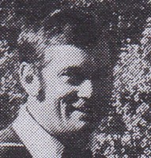
Graduated from Dwellingup Forestry Cadet School in 1965. Worked for many years as a technical officer in the research branch. Worked with CALM Vegetation and Tree Planting Advisory Service in late1980s. Transferred to Silviculture Branch in Como in 1990. Moved to Karratha as the Department's first officer in the Pilbara, in mid 1990s.

